ASSP NC | AMERICAN SOCIETY OF SAFETY PROFESSIONALS
NEWSLETTER
SEPTEMBER 2026 EDITION
September brought a wave of engagement for the ASSP Nigeria Chapter — from institutional partnerships to hands-on learning for the next generation of safety professionals. Here's a look at what happened, and what it means for the profession ahead.

IN THIS ISSUE
• Strengthening Collaboration — FRSC Courtesy Visit
• Learning Through Practical Safety Case Studies
• Investing in Emerging Safety Professionals
• Women in Safety: Launch of the WISE 2026/2027 Programme Year
• Students Section: Charting the HSE Career Pathway

STRENGTHENING COLLABORATION THROUGH PROFESSIONAL ENGAGEMENT  September 4, 2026  The Chapter paid a courtesy visit to the Federal Road Safety Corps (FRSC), RS6 Headquarters in Port Harcourt, meeting with Assistant Corps Marshal and Zonal Commanding Officer Henry Benamaisia. The conversation reinforced a growing partnership centred on knowledge exchange, professional development, and shared advocacy for road and workplace safety.  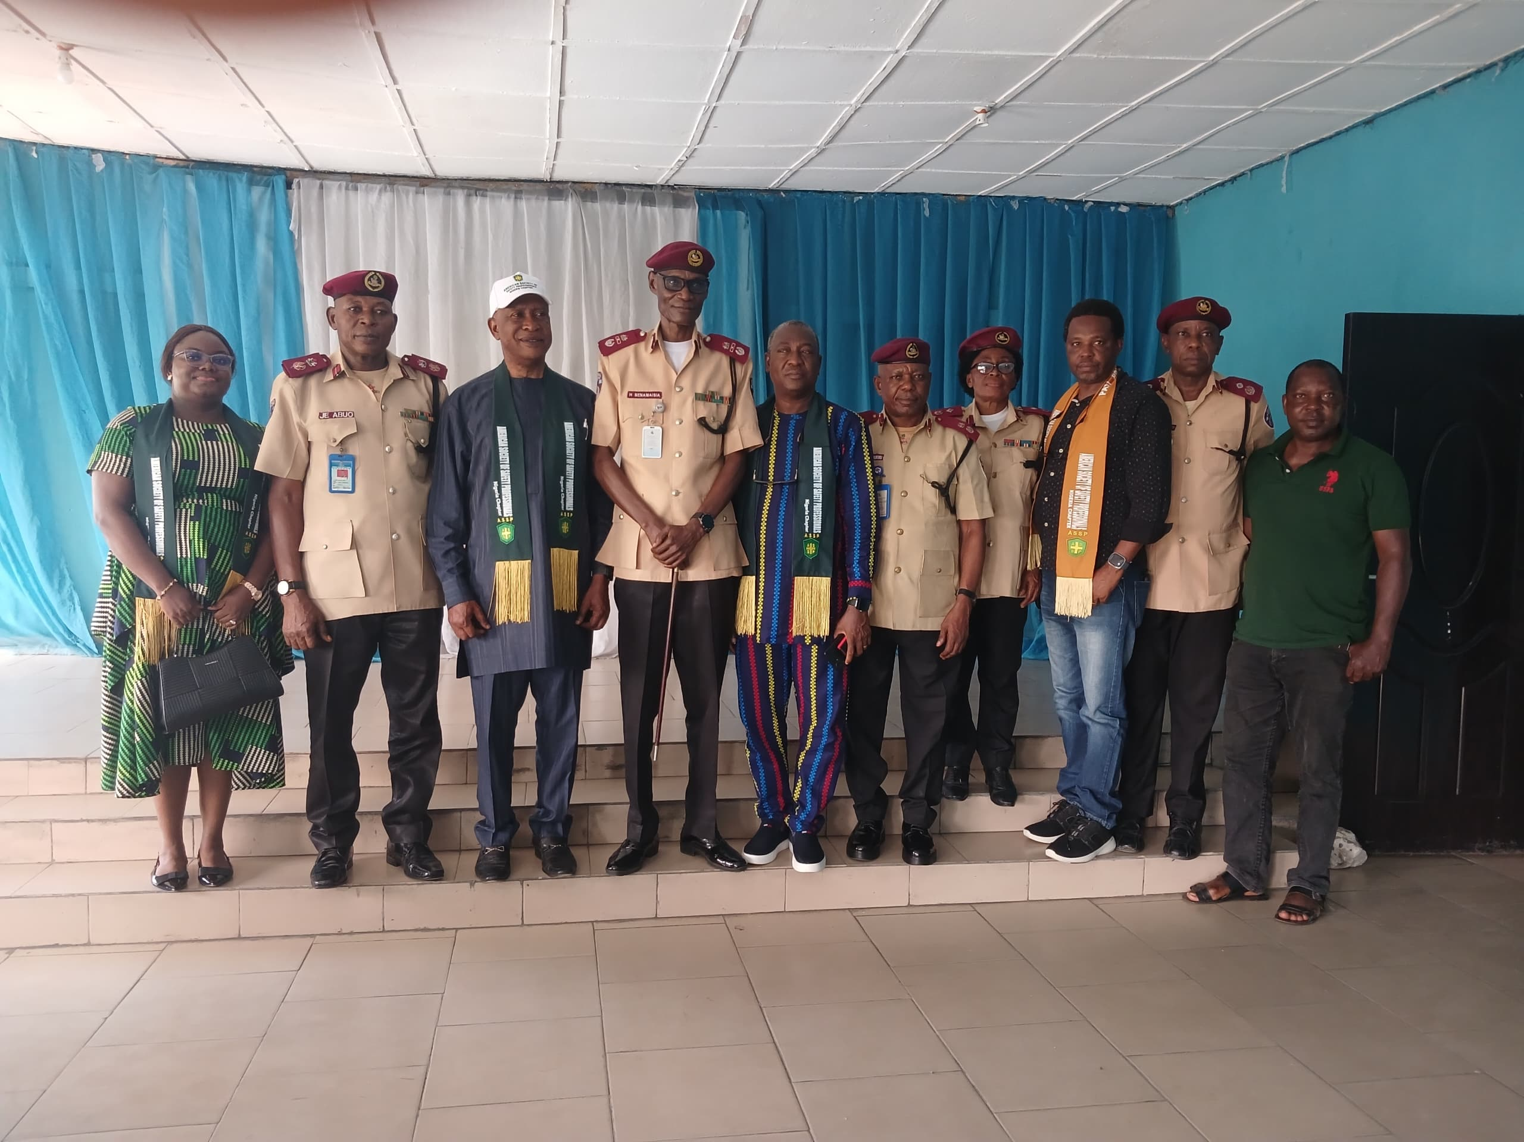  LEARNING THROUGH PRACTICAL SAFETY CASE STUDIES  September 19, 2026  A virtual Safety Case Studies session put theory into practice. Mr. Gospel Mangibo unpacked home and fire safety within the Nigerian context, sharp reminders that hazard prevention starts close to home, and that effective controls should be in place. |  | WOMEN IN SAFETY: CONNECTING, LEADING, SHAPING SAFER WORKPLACES  September 27, 2026  The Women in Safety Excellence (WISE) launched its 2026/2027 year under the theme "The Safety Nest: Connecting Women, Building Leaders, and Shaping Safer Workplaces". WISE serves as a platform for women in the profession to connect, learn, grow, and lead.  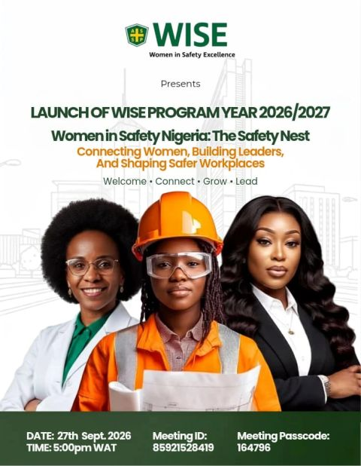  STUDENTS SECTION: CHARTING THE HSE CAREER PATHWAY  PTI Campus, Effurun  The ASSP NC Students Section hosted a technical session on the HSE Career Pathway, opened with remarks from Chapter President Dr. Victor Egbe, read by Students Advisor Dr. Godwin Birma. Facilitator Engr. John Erhekpaine drew on years of field experience to walk students through the road ahead, fielding questions before a well-attended room.
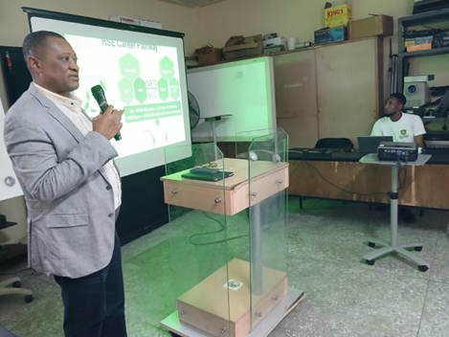 |  | INVESTING IN THE NEXT GENERATION OF SAFETY PROFESSIONALS  September 26, 2026  The Young Emerging Professionals Workshop equipped students, graduates, and early-career professionals with practical tools to stand out: CV writing, LinkedIn optimization, and putting AI, research, and innovation to work in a safety career. Facilitators Adedeji Moses Aderinale and Ajimituhuo Jibril delivered sessions built for today's job market.  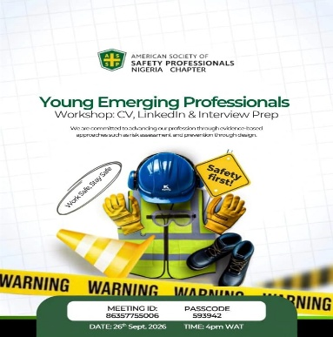

WHAT'S COMING UP
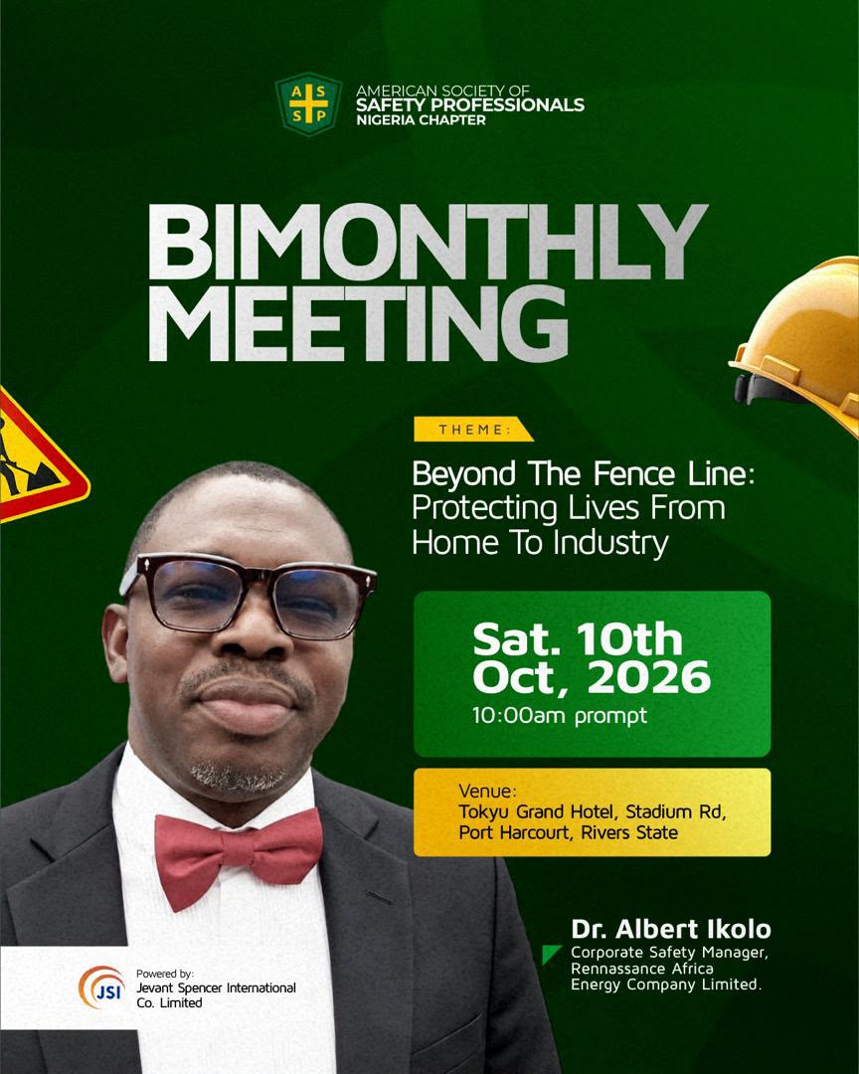  Bimonthly Meeting — Sat. 10th Oct, 2026  Tokyu Grand Hotel, Port Harcourt | 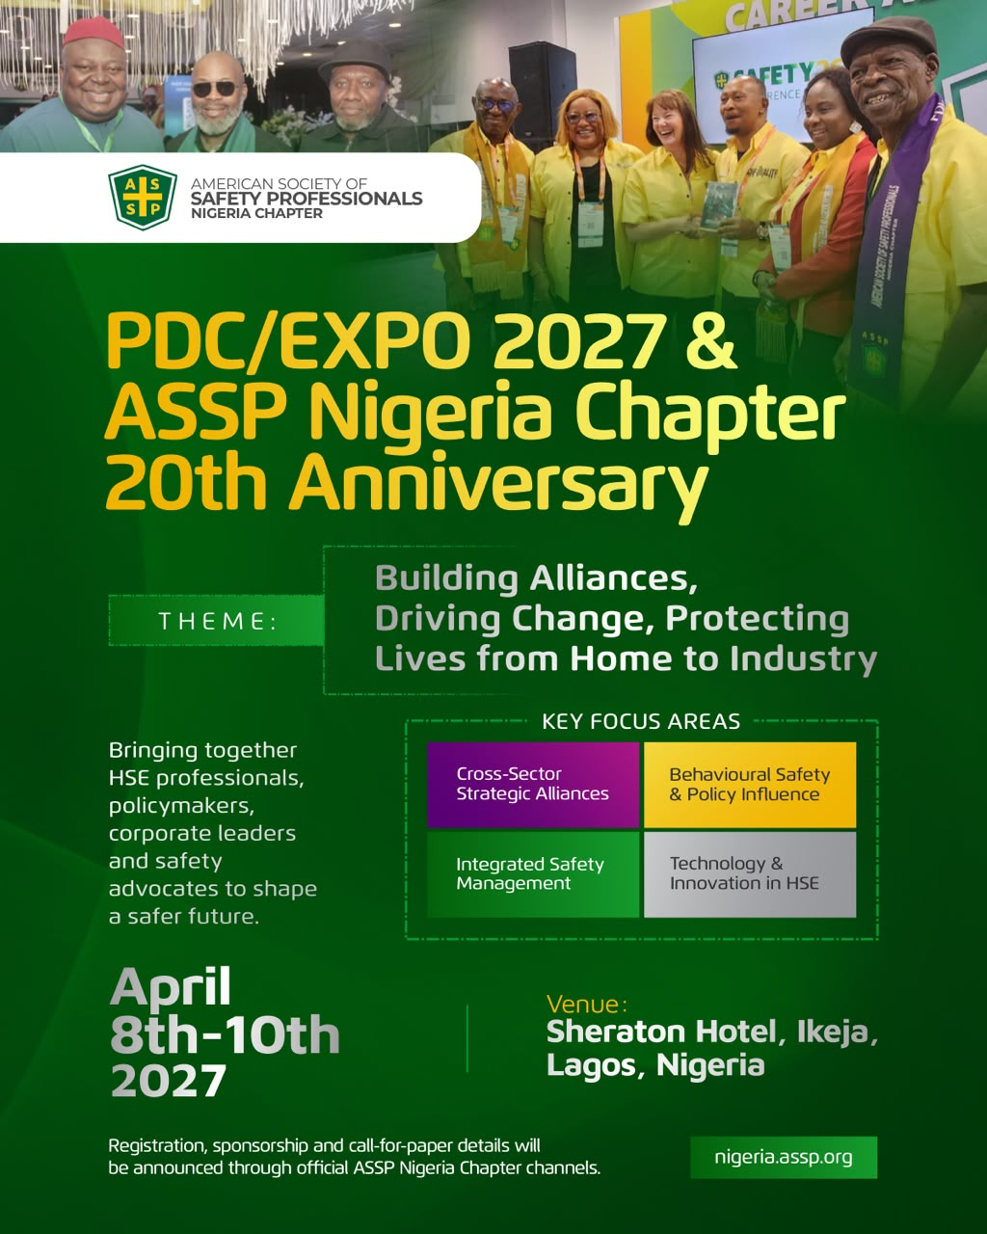  PDC/EXPO 2027 & ASSP-NC 20th Anniversary  April 8–10, 2027 — Sheraton Hotel, Ikeja, Lagos

ASSP NIGERIA CHAPTER
Advancing Safety. Building Professionals. Strengthening Communities.
Stay safe. Stay connected.

